Project Name: | Feasibility Study and Detailed Design on the Improvement of the National Road No. 67 (NR67) (Section of Siem Reap – Anlong Veng – Choam/Sa Ngam) Project
Country: | Kingdom of Cambodia
Status: | Drafting the Terms of Reference (TOR) Tender Consultants  Supervising/Examination Completed
Executing Agency: | 1) Implementing Agency: Ministry of Economic and Finance (MEF)  2) Executing Agency: Ministry of Public Works and Transport (MPWT)
Scope of Works: | - Feasibility Study; related data collection, review the feasibility study of the project that carried out in 2006, collection and analysis of socio-economic data, study and analysis on traffic and transportation, engineering aspect, Initial Environmental Examination (IEE), project feasibility study, project value addition approach, future bilateral benefit, problems and barriers that may arise during working process, and public relations  - Detailed Design; alignment and level survey, material survey, design task (structure, road stability/settlement, bridge, drainage system, junction, traffic/street light, safety), preparation of Right of Way, land use and resettlement plan, construction detailed copes, quantities of works and cost estimation, and preparation of bidding document
Date of Approval: | April 18, 2018
Amount of Loan: | 13.80 Million Baht
Net Commitment: | 13,411,487 Million Baht ( VAT included )
Name of Consultants: | Team Consulting Engineering and Management Public Company Limited (Lead Firm) together with TLT Consultant Company Limited
Contract No: | 1/2562
Contract Signing Date: | October 19, 2018
Period of Consulting Services: | 180 Days
Starting Date: | October 22, 2018
Ending Date: | April 19, 2019
Project Benefits: | - To enhance the capability of passenger travel, logistic, and services.  - To enhance the benefits on route tourism and border trade  - To enhance the expansion of communities along alignment
Operating Results | Completed
Result of the study | www.nr67.net

Project Area and Route Alignment
Ending point
Choam/Sa Ngam border pass
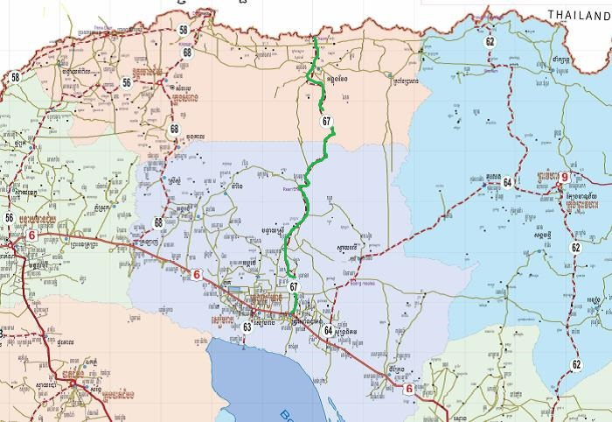

Starting point
NR6 intersection

Existing road of NR67
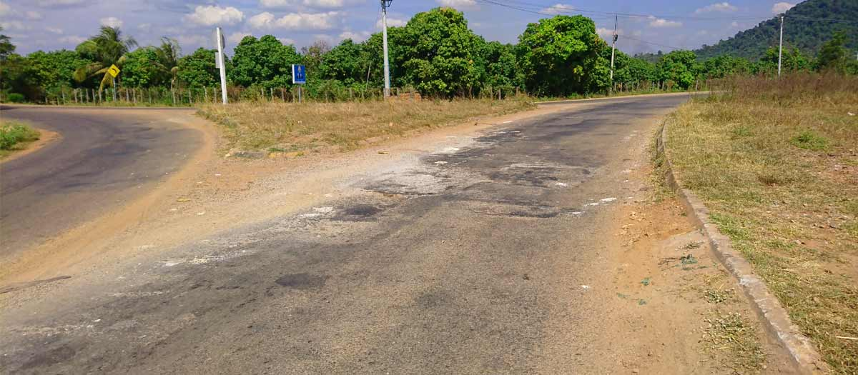

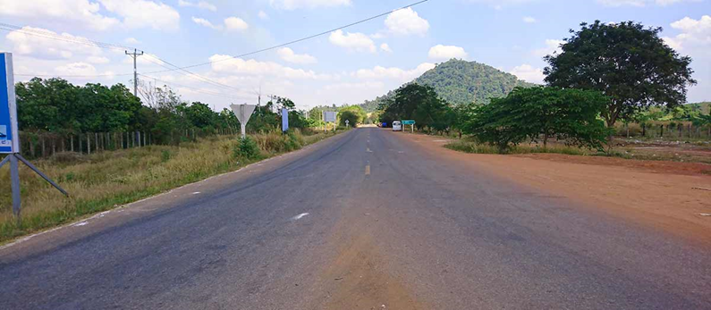

Project Design

